Here are a few tips from Troop 212 to help you select the proper equipment for your son to use on backpack trips with the troop.

You can equip your son for a very reasonable price, and you don’t have to buy all the equipment at once. Garage sales are good places to pick up some great deals but take care not to waste your money on outdated or worn out gear.

Since there are literally millions of Scouts and since they ALL camp, the major camping gear makers (especially Coleman) carry special lines of good, boy-sized equipment at affordable prices. Much of it even has the word “scouts” or “scout sized” on it.

To get started and since you may not know what brands of equipment are good for your son to use, you may want to consider renting equipment. REI or Sports Chalet is very reasonable. (About $12 per day and $5 each additional day for a good backpack last I checked) And they will custom fit the equipment for your son. He can give the equipment a test run and see if he likes it.

THE BARE ESSENTIALS

As you start shopping for equipment this is the order of importance in which you should buy:

1. SLEEPING BAG - a good bag is a must. But you don’t have to spend a great deal of money to get a decent one. We recommend a bag that is rated for at least 30 degree weather and weighs about 4 pounds or less. Target, COSTCO and Sportsmart are good places to shop. Remember that if your son is going to backpack with the troop, the lighter and smaller the bag is the better. If the bag does not come with a stuff sack, then buy one. Stuff sacks come in various sizes so after you buy the sleeping bag and stuff sack, stuff it while in the parking lot to see if it fits well. The sack will keep the bag clean and dry as your son comes and goes from a camping trip. Sleeping bag prices range from $20 to hundreds of dollars. Coleman makes a zero degree, 5lb bag that sells at Target for $70 (last I checked). Stay away from the heavy, bulky and cheap $20 bags; they are the WORST thing for backpacking and provide no warmth whatsoever. Your son won’t sleep well and won’t like to camp.

2. SLEEPING PAD - for placement underneath your son’s sleeping bag. This is necessary not only for cushioning, but for warmth. Without a pad you son is sleeping on very cold ground. However, DO NOT send him with a cheep air mattress. They puncture easy and the air becomes cold. A tight-cell pad does not have to be thick to work. Suitable pads can be found at Target for under $10. More high tech thin, self-inflating pads can be found at better sporting goods store. Pads should be small and very light weight (most are only a few ounces) and take up very little space. Never send a bed pillow either. He can roll up his jacket and stuff it in a shirt covered stuff sack.

- BOOTS - are the single most important piece of backpacking equipment there is and are essential to any safe, comfortable camping trip. Once again, they range in price from cheap to outrageous. Watch for sales. Also, please, please don’t buy the boots too big thinking he will grow into them. It’s okay to buy them a little large, but have him wear two pairs of socks. The last thing that you want is to have your son’s boots sliding around when he walks. This will cause serious blisters and various other aches and pains for your boy.
4. BACKPACK - a good pack can make the difference between a miserable experience or a great adventure for your son in the wilderness. When selecting a pack:
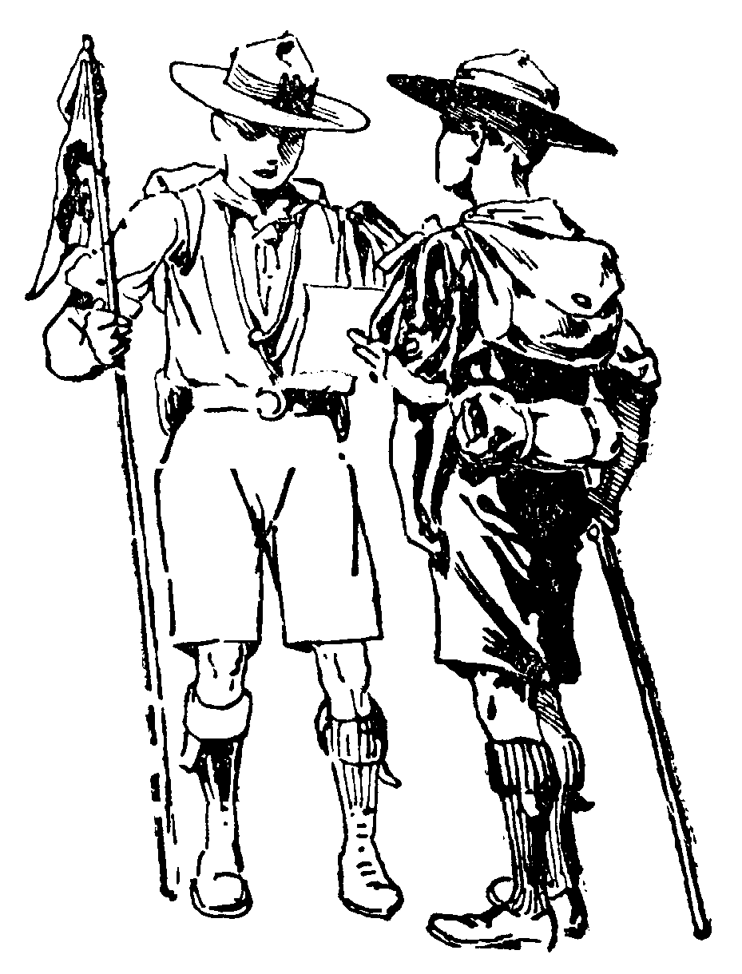

- Have your son try on the external frame pack at the store and make the store personnel load it up to verify the fit.  - Make sure the pack fits snugly around your son’s hips. This is where he will carry the total weight of the pack. It is essential that the padded waist belt fits well.  - Make sure the shoulder straps are not draped to the back side of his shoulders. They should actually extend straight back. Otherwise this means he is carrying the weight of the pack on his shoulders instead of his hips.  - Keep in mind he is growing so if possible, look for a pack that will expand and straps that have long tails.  - Make sure the pack is not too big and roomy. This leads to the temptation to overload it and it will shift on his back.  - Remember that the total weight of the fully loaded pack should not exceed 30-35 pounds (or 1/3 +/- your son’s body weight). 25-30 pounds would be best for some of our smaller kids.  - Watch for sales. Decent packs range from $90 to $200. Stay in the cheaper range since your boy will outgrow this pack in a few years. |  | - Get confused between a backpacking pack and a day pack. Ask for help from the store personnel. And I am sorry to report that you CANNOT get a backpacking type pack at Target.  - Borrow a pack from an adult and expect it to be usable by your boy unless he is a teenager (aka a boy in an adult body). If you must borrow one, adjust it to fit. Be alert to the fact the padded waist strap MUST fit snugly.  - Let you son overload his pack and don’t YOU overload his pack. He really won’t need too many pairs of extra socks or that Army blanket. (The blanket is too heavy and guess again if you think he will change socks on a campout unless he steps into a creek and even then....)  - Let you son wear the waist strap under his belly. Some of our guys have tummies already and are used to wearing their pants underneath their gut. They absolutely cannot wear their backpack like this as it will put the weight of the pack on their shoulders. Make sure they know to put their packs on with the buckle over their belly buttons.
DO - DO NOT

Good places to purchase packs include: Sports Authority, Big 5, REI, and Army/Navy Surplus Store. There are also consignment sporting good stores around such as Play It Again Sports. (Page 228 of the Boy Scout Handbook shows a picture of an external frame pack. These are the least expensive and easiest for the boys to use.

- CANTEEN/WATER BOTTLE - This should be a good quality water bottle that will fit easily into a backpack and will not leak. Page 209 of the Boy Scout Handbook shows a good water bottle. The opening is the right size for our troop water purifiers to fit on.

- FLASHLIGHT (and extra batteries/bulb) The troop provides lanterns to light the camp at night, but those after-dark trips to the outhouse make the use of a flashlight necessary. Also, it is against BSA policy (and safety rules in general) to have lanterns (flames) inside tents. His flashlight will be the only way your boy will have light in his tent and/or be able to find his way to the outhouse (or the nearest bush) in the dark. Maglites are the best brand and they come in all sizes. A favorite is a mini-Mag. Shy away from D-cell battery flashlights due to their weight.

- MESS KIT & EATING/COOKING UTENSILS - You don’t have to spend a lot of money. A decent, lightweight mess kit is under $10 and available at stores like Target (do you get the feeling I spend a lot if time in Target?). These come with a drinking cup, a small pan with lid, a plate and a skillet. Don’t forget a knife and fork and a large spoon for cooking and eating. Another must-have is a pot grabber. This is a device that looks like a pair of bent pliers that holds onto the side of a pan and keeps the pan from rocking and spilling. They cost about $2. Page 264 shows a picture of a mess kit and Lexan eating utensils.

8. STOVE - It is the consensus in our troop and with many other Scouters who backpack that the best stove for boys to use is the Bleuet stove. This is due to the ease of use as well as the cost. I have recently seen them on sale at REI for $20. They work by being attached to a canister of propane/butane mixed gas. This makes them REALLY easy to use. There are other brands of stove that use the same principle but the Bleuet has the fewest “moving parts” and this is part of its charm. You may know an adult who considers himself a serious backpacker and he will tell you that the best stove to use is a Whisperlite. Problem is that this brand and others like it require LIQUID FUEL. We have heard lots of stories about grownups setting themselves on fire with liquid fuel. We don’t even want to think about a 12-year-old boy trying to use the stuff or carrying it around in his backpack. And the Whisperlite has loads of moving parts anyone of which can cause the stove to malfunction when on a campout. (Page 253 of the Boy Scout Handbook shows a picture of the stove NOT to buy.)

9. TENT - For all regular campouts the troop provides the tents and insists on providing tents for the boys to use. However, for backpacking these tents are very heavy and way too big even when split between two boys. Most of the time just a ground cloth and a sleeping pad under the sleeping scout works well. However, if your boy is interested in going on all troop backpacks, you may want to look into a small, one-person tent that weighs four pounds or under. And don’t be confused when the tent box says “two people.” This really means “one person and his/her stuff.” (Page 238-39 of the Boy Scout Handbook show pictures of different types of tents. The dome tent featured comes in all sizes from one-man to family sized.)

There are some good buys on inexpensive, small tents to be had. However, watch out for cheap tents because the window mesh is sometimes second-rate and will let mosquitoes, ants and ticks through.

Also, consider a bivwack single person tent. Wentzel makes one that Sportsmart sells for about $30. The troop owns 10 of these for boys who cannot sleep “out” under the starts or who do not have their own BP tent. Or an indulgent grandparent may want to consider as a special birthday or Christmas present, one of the more expensive backpacking tents that are available. Like all other camping gear, tents range in price with decent ones selling for $100 and up. The most expensive tents are the all-season tents. As yet we have no plan to backpack in the Arctic, so a $500 expedition-quality tent would be total overkill.

Make sure you buy a small tarp to go under any kind of tent to serve as a ground cloth. Buy a plastic tarp that is the same size as the footprint of the tent or as close as you can get. A good place to find a blue $10 tarp is at Harbor Freight on west side of Woodruff just north of Carson Street. A plastic tarp will protect the bottom of the tent from tearing on sharp rocks and will give an extra added layer of insulation against the cold ground. If the tent has a nylon floor, the tarp will keep the floor dry.

CLOSING THOUGHTS:
Your best reference guide on clothing needs and camping gear needs is – the Boy Scout Handbook. Not only does it show the equipment but it also describes its use and proper care. At our weekly meetings we often discuss equipment and gear so you may want to consider sitting in on those nights to see what other members of the troop use.

Since your son is getting older, it is probably getting a little difficult to know what to get him for Christmas or birthdays – he is too old for toys and too young to want clothing. Camping gear is the best gift, especially because of the range in price from a dollar or two to, well, up there. Next time Aunt Martha or grandpa asks for a gift suggestion, mention padded hiking socks or a thermal sleeping pad.

