
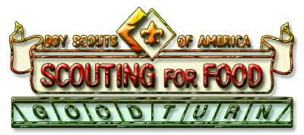
Scouting for Food
November 7, 2009

Scouting for Food is a part of the BSA’s Good Turn for America held annually to give goodwill and to “help other people at all times.”

Purpose: To help fight hunger in the Long Beach Area Council is supporting Project Shepherd, while teaching Scouts the value of the Boy Scout slogan, ‘Do a Good Turn Daily’.

Food Items: Canned and Dry Goods Only. Here are some examples:
- Soup - There are many varieties of soups available
- Tuna, chicken or other luncheon meat - Canned salmon is very healthy
- Fruit - Great replacement for produce
- 100 percent fruit juice - Pure orange juice contains vitamin C
- Vegetables - Definitely a plus for healthy foods
- Evaporated milk - Excellent source of calcium and protein
- Non-perishable food items (sugar, flour, rice, and beans)
- Any other nutrient meal food
- Please no perishable, frozen or glass.

WHAT IS SCOUTING FOR FOOD?
The word "Scouting" in Scouting for Food is derived from the Boy Scout movement. It is the Boy Scout organization that makes Scouting for Food a success. "Scouting for Food" is Scouting's community stewardship project aimed at addressing the problem of hunger in the community in which you live and work. The Scouting for Food campaign is a food collection effort carried out by Boy Scouts and Cub Scouts from your community.

WHY SCOUTING FOR FOOD?
Scouting for Food is a project rooted in the very foundation of the Scouting movement. Through initiative and hard work, the Boy Scouts have developed a framework that can feed tens of thousands of needy local residents with emergency aid. It is up to the people of your community to make Scouting for Food a success.

FOOD DROP-OFF DAY: November 7, 2009
Please Support the Boy Scouts Collecting Food for Project Shepherd

Polaris District Drop off location: Mayfair Park 5720 Clark Ave. Lakewood CA 90713
Contact: Margo Geesing (562) 428-3441

