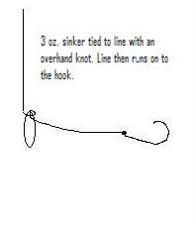
Simple Ocean Rigging

This is the most common simple party boat rig for sand bass.
You can use any type for sinker. We are suggesting that our whole group use 3 oz. sinkers so our lines drift the same and tangle less.

Suggested hook size is a 1 or 2. If you have a 1/0 or 2/0 on hand, you can take advantage of the few larger baits in the tank.

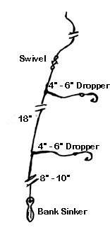
There are many variations on rigs. See the internet for variations. The boat captain suggested using 12 to 20 pound line and rigs. His experience is that many people use too heavy of gear for bass.

This slightly more complex rig uses two hooks with the sinker at the bottom. Again the same size hooks and sinkers are suggested. I typically use a snap swivel at the top of this rig so I can change to a jig or lure if the fishing action varies.

The leader lines can be attached with a knot known as a drop loop or a three way swivel. These rigs can be bought pre-made also.

The basic fishing technique will be to drop the rig to the ocean floor and then bring it up one or two cranks. The motion of the boat in the water’s surface will create all the jigging action needed to present the bait well.

Simple Ocean Rigging

This is the most common simple party boat rig for sand bass.
You can use any type for sinker. We are suggesting that our whole group use 3 oz. sinkers so our lines drift the same and tangle less.

Suggested hook size is a 1 or 2. If you have a 1/0 or 2/0 on hand, you can take advantage of the few larger baits in the tank.

There are many variations on rigs. See the internet for variations. The boat captain suggested using 12 to 20 pound line and rigs. His experience is that many people use too heavy of gear for bass.

This slightly more complex rig uses two hooks with the sinker at the bottom. Again the same size hooks and sinkers are suggested. I typically use a snap swivel at the top of this rig so I can change to a jig or lure if the fishing action varies.

The leader lines can be attached with a knot known as a drop loop or a three way swivel. These rigs can be bought pre-made also.

The basic fishing technique will be to drop the rig to the ocean floor and then bring it up one or two cranks. The motion of the boat in the water’s surface will create all the jigging action needed to present the bait well.

