Troop 212
Chantry Flat Backpack Trip December 2012

Dear Scouts and Scouters,

Our December backpacking adventure involves backpacking from the Chantry Flat trailhead to the Spruce Grove Campground in the Angeles National Forest. This will be a great “entry level” hiking experience.

On Saturday morning we’ll meet at 6am at the Church parking lot and drive to the trailhead. We need parents who are not backpacking to transport hikers and their gear to the trailhead, AND those or others to retrieve us on Sunday! It is a mere 35 miles from the church lot to the trail head. Please make sure scouts eat breakfast before we meet - we will not be stopping en route.

When we arrive at the trailhead, we will be at an elevation of about 2,060 ft. From there we will hike approximately 3.6 miles to our camp site, initially downhill, but ultimately camping at about 3,000 ft. Scouts will make Base Camp, then continue the hike to the top of Mt. Wilson carrying daypacks with water, lunch and the “ten essentials”. Scouts should plan they will travel another 3.3 miles uphill to about 5,700 ft. and (of course) 3.3 miles back to Base Camp. Sunday morning we will eat breakfast, break camp and hike back to the trailhead. We should be at the trailhead ready for pickup by about 11:30am. We will stop for lunch on the way back home on the road, and scouts should bring money for that lunch. Hikers will organize and re-store troop gear on return that same day at the Church parking lot, with the exception of the troop backpacks, which need to be returned to the troop the next day, Monday, during the troop meeting.

For this trip, troop packs will be handed out at the meeting on Monday December 3 - to facilitate a demo that focuses on preparing correctly for hiking and sleeping in inclement (cold and wet) weather. On December 10, scouts will bring their properly packed packs for wet weather to the meeting for an initial review of how well they have packed. Our standard mandatory final “bag check” will be held Friday December 14, where we will also distribute food, stoves, fuel, and tents - enabling hikers to finish their packs before we depart early (and rapidly) Saturday morning.

Mid-December temperatures in the area range from the 30’s to the low 60’s during the day and in the low 30’s to low 40’s at night, and rain is also VERY possible.

Pack Distribution: Monday December 3 at regular meeting – Initial attendance list will be set as payment and permission slips are collected. Troop packs will be distributed. Meal/cooking gear teams will be arranged. Food menus will be set.

Cost: $15.00 / $10.00 ($15 includes 1 trail lunch, 1 trail dinner 1 trail breakfast,) ($10 for gas). Please bring $25.00 cash to the troop meeting on Monday, December 3, with the standard permission slip which can be found on the website.

Initial Bag Check: Monday December 10 at regular meeting – Scouts should bring their packs packed as they believe appropriate for the backpacking trip (including weather proofing). Updates tot he attendance list will be accepted as any last minute payment and permission slips are collected

Food Shopping: We will meet at 7:00 PM, at Stater Bros.on Thursday, for food shopping. This will be an easy and short shopping trip since the boys will use the agreed upon food lists, and the Main Course Supper pouch will be purchased by the Adult Team, for distribution on Friday’s final bag check. At the completion of food shopping, the food will be stored in John’s van, for delivery to the Church meeting room the next day in time for repackaging and bag checks

Final Bag Check: Friday December 14, at 7:00 PM –We will meet in one of the Church meeting rooms to distribute additional troop gear and food, and then repack the backpacks accordingly.

Departure: Saturday, December 15, at 6:00 AM – Church parking lot. Please arrive promptly for quick visual pack inspection and vehicle loading. Be sure to have filled canteens or hydration packs for the hike before you leave home ! Parents who will shuttle hikers to and/or from the trailhead instead of hiking with us, please notify Joe Gawel (Francesgawel@verizon.net) or Dan Passage (dan.passage@bingham.com) which leg(s) of driving you will handle, and how many hikers and backpacks you will transport.

Return: Sunday, December 16, at trailhead at approximately 11:30. Drivers - please be there. We cannot leave the trailhead if any scouts lack a seat! Back at Church Parking Lot approximately 1:30 PM. Done with gear reorganization by about 2:30.

Location: 605 Freeway North to 210 Freeway East. Exit N. Santa Anita Avenue, and head North into the mountains. Turn onto Chantry Flat Road about 4.5 miles up into the mountains.
.
Uniform: Class B or gray tee shirt.

At a minimum, the following items should be packed in a backpack (NO black duffel bags):

◻ Appropriate clothing  (Day mid-60°/Night mid-30° - possible rain)  ◻ Brim Hat (suitable for rain!)  ◻ Pocket Knife  ◻ Flashlight (small is best)  ◻ Sunscreen and Chapstick  ◻ First Aid Kit  ◻ Compass  ◻ Hiking boots, extra socks | ◻ Ground Cloth  ◻ Poncho/Rain Gear  ◻ Daypack  ◻ Small baggy of Handy-wipes, Toothbrush & paste  ◻ Toilet paper & trowel  ◻ Canteen filled with water  ◻ Mess Kit (utensils, bowl, mug, etc)  ◻ Scout Handbook  ◻ Whistle | ◻ Insect Spray  ◻ Warm Jacket  ◻ Matches or Flint  ◻ Pencils, Pens, Notebook  ◻ Rope – 10 Feet  ◻ Warm Sleeping Bag and Pad  ◻ 2 Small towels  ◻ Sunglasses

Troop owned backpacks will be available at the troop meeting on Monday, December 3. Other troop owned equipment (tents, water filters, stoves and cook pots), will be distributed Friday evening during the final equipment check. There is no need to purchase a backpack or other equipment for this event - the troop owns enough. It will be cold at night. In fact, it may be cold and wet the whole time. Please keep in mind that a full backpack should weigh no more than one-fourth the weight of the scout carrying it - and remember to plan for carrying your share of food and troop gear distributed Friday!

As is the tradition of Troop 212, this will be a very safe outing. If you have any questions, please contact Joe or Dan
(refer to the ScoutTrack directory for phone numbers).
Yours in Scouting,
Joe Gawel & Dan Passage

Map to Trail head: Map of beginning of trail:

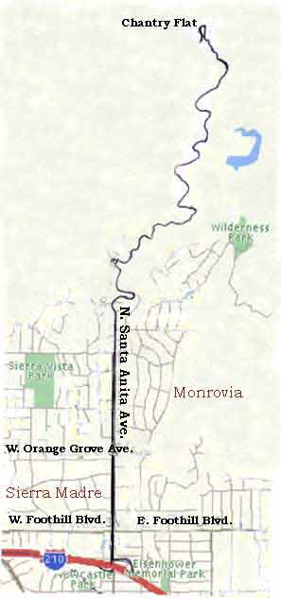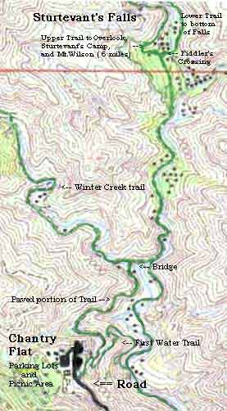

Map to Spruce Grove Campground:

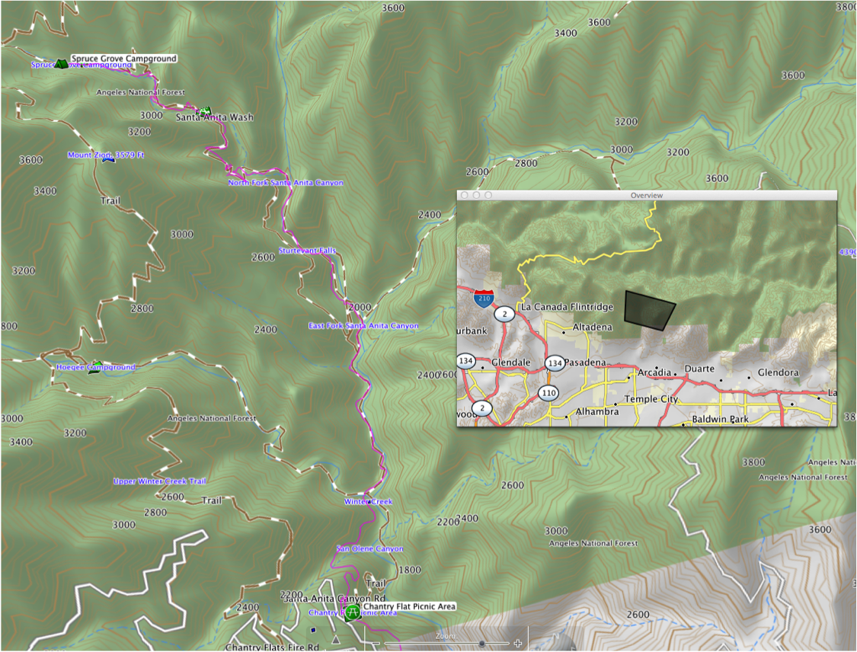

Link to map of circuit hike from trailhead to Mt. Wilson and return (using Winter Creek Trail):

http://www.everytrail.com/guide/mt-wilson-via-chantry-flats

