Sunday, February 26th, 2012 at SNOW SUMMIT

Overview & Required Forms

A greeting to all, here’s a review of information & directions to get signed up for this year’s family
Snow Sports day @ SNOW SUMMIT. This is a family event so all are welcome.

Helmets are Mandatory for all Scouts per the Guide to Safe Scouting (revision date 08/19/2009). For the first time, Snow Summit does rent helmets, so additional information under equipment rental will be posted to help you if you chose this option.

It is highly recommended that New Boarders and Skiers take lessons. The price is right and it’s a safe way to learn with trained instructors.

What do you need to do?

1) Release Waivers
a) Group Ticket & Lesson Release Waiver: Fill out completely ONE per person including
Adults. Parent or guardian must sign for minor.
b) Troop212 Permission Slip: Fill out completely ONE per Scout.

2) Rental Forms for those who need equipment.
a) Fill out the “Guest Info Sheet” page completely ONE per person (You keep this form with you and hand it in when you pick up your equipment).
b) If you are renting a helmet then you need to fill out the separate Helmet Rental
Waiver (You keep this form with you and hand it in when you pick up your equipment, please note: minors will require a responsible adult to be present).
c) Purchase of a damage waiver for each set of equipment rented is mandatory.

3) Payment Schedule – Review the cost schedule and select the package(s) for yourself and/or your family. Please fill out the quantity and totals on your cost schedule form. This should match the payment you submit. Please remember to include the mandatory damage waiver cost for each set of equipment rented. You will need to also need to complete and submit a “Participant Form” for each person in your family group

4) Submit all completed forms and payments to Randy or Gloria at or before the troop meeting on MONDAY, JANUARY 23, 2012.

This event starts at the hill and participants need to arrange transportation to and from the event. If you need help arranging a ride to the event, please let us know and we can help you. Please note we are still checking into a bus service for those who may want it (details to follow). Directions along with any other mountain info, including additional forms if needed, are available
@ the SNOW SUMMIT web site www.bigbearmountainresorts.com.

We meet on the top deck of Bear Bottom Lodge (near chair 11 and 2 – see map on next page) starting at 7:30 AM. People can arrive anytime but Scouts need to check into get credit for the event and sign up for the field part of merit badge if they are interested.

Adult Theme Leaders

Randy Galisky, Gloria Galisky & and Ali Ghandchi
(Refer to the ScoutTrack directory for phone numbers.)

Sunday, February 261
h,
2012 at SNOW SUMMIT

T H E
BASE

A R E A

......l......l......
: ADULTSKI :
n :
: n!OOL
W:
: (EMcpl
BEAR BOTIOM LODCE
MAINFLOOR
Ra1t<1HM1U
ear ,na
Oat-B-Qu t
PhonG

' ............. 0 SNOWB,OARDS)_R; _GEI
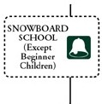

GROUND FLOOR

.·······-.
18 Z

: w :
BEAR LODGE

C·I.IA.JR
: SpUc itor:
:.. An-.1 ·
CHAIR : f!'! :
1 ti-J ;sMAJ<I GUESTREL\TIONS
- -=...1 ...... ............•. SIGN
Li1dc Bur C.mp
2ND FLOOR
Opcn1iom
JRDFLOOR
s. kc ch«k
"'''"

.........

SNO·
CENTER
..ndfloor)
<==== (Gro
«

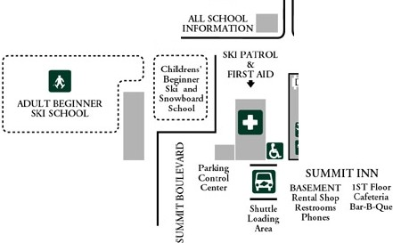

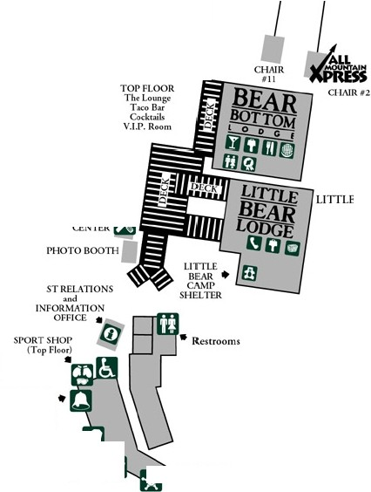
3 WAYS TO BIG BEAR! HWY 330/18 FROM SAN BERNARDINO THROUGH RUNNING SPRINGS- (front way) Shortest and most direct route.
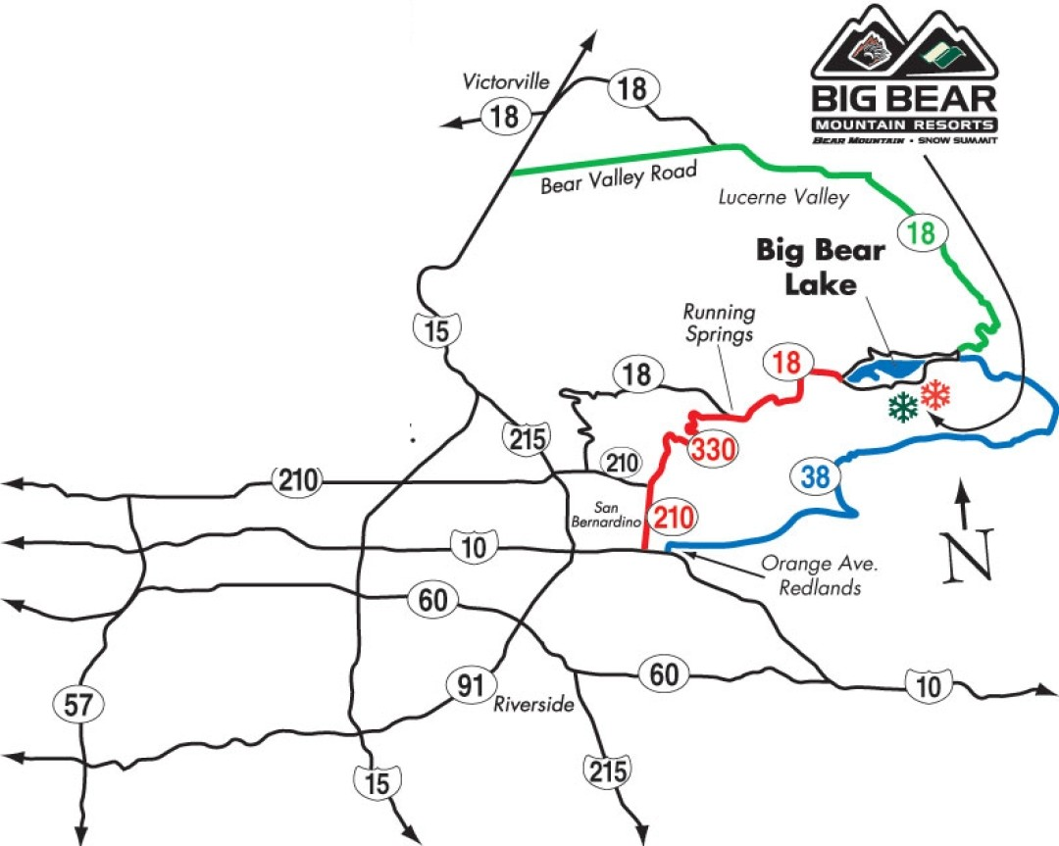

HWY 38 FROM REDLANDS- (Back way) Best route when leaving the valley on weekends and holidays.
HWY 18 FROM LUCERNE VALLEY (Desert way) Best in snowy weather.

1:1\"DFLOOR
Bullwh«<B•
MAJ. ;.: .0.• • f- ND

210>-- o'----

