Troop 212 Day Hike
Dripping Caves

When: Saturday September 15, 2012 7:00 am -2:00
Leaving & Returning: Church parking lot at 7:00 am – 2:00 pm
Where; Dripping Cave in Aliso & Wood Canyons Wilderness Park
28373 Alicia Parkway Laguna Niguel, CA 92677 Ctrl & click to get map http://mapq.st/OE3z8e

Trailhead: From Interstate 5: Take the Alicia Parkway exit. Head south. Five miles (about 100 yards past the intersection of Aliso Creek) south brings you to the entrance to the parking area, next to a church. Parking is $2. Be sure to visit the museum which features the skeleton of a ground sloth, named Waldo, discovered during the construction of the Foothill Transportation Corridor. Admission to the Museum is $2 per person or $4 per family. The trail begins just beyond the picnic area. (Lat:33.551343 Lon:-117.72053)

Agency: Aliso & Wood Canyons Wilderness Park
Distance: 5 miles round trip
Elevation gain: 290 feet
Hike Time: 2.5 hours
Difficulty Rating: Easy PG
Suggested time: 2.5 hours

What to Bring:
- Signed permission slip
- Class B uniform
- Daypack with 10 essentials
- Extra water, snacks, hat, sunscreen
- Money for parking $2.00-5.00 and Museum $2.00 per person if interested

Map &Compass – if you are planning on advancement bring your compass and map. When you reach the trailhead, note on the map the general direction of the trail, then use your compass periodically to make sure you are still heading the right direction. If you get lost, you can also use the compass to find you position on the map by taking bearings.
First Aid Kit - This is a must take item. For those new to hiking, make sure the kit contains moleskin, and indispensable solution for blisters on the trail
Sun Protection - Don't forget a hat, sunscreen, and sunglasses.
Cell phone - for emergency only.
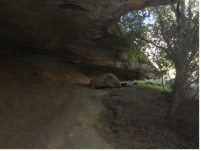
Contact information: Linda Kocisko –(562) 221-9587; Dan Passage - (213) 304-7909 and
Richard and William Greenwood – (562) 477-8072

