Dear Scouts and Scouters:
2016 Troop 212 Summer Camp BSA Swim Test
Summer Camp is fast approaching and this year in order to get all attendees prepared for having a great time at camp we are conducting our own Troop 212 BSA swim test. Completing this test prior to the camp arrival will help expedite the camp check in process as well as providing a warm, sea level, relaxing environment in which to test. Therefore, all individuals attending summer camp this year should also attend this swim test event. Please also note, this is a great opportunity to complete the swim test requirements for first and second class rank advancement. Go to camp and do rank advancement all in one shot. You may attend even if you are not going to camp.
The test will take place on Saturday, May 28th from 12:00pm to 1:30pm. Troop 212 has two lanes reserved at the Belmont pool located in Belmont Shore 4320 East Olympic Plaza LB CA 90803. Remember this is the second event taking place on the 28th of May. The other is flag planting in LA (see trip letter) The time for the BSA swim test has been planned to give scouts ample time to make the flag planting event and then get back to Long Beach to complete the swim test. Parking at the pool can be done in the metered parking lot south of the pool (be sure to bring quarters for meters, this will be the only cost for the event) or on the street adjacent to the pool. The test consists of jumping feet first into water over the head in depth. Level off and swim 75 yards in a strong manner using one or more of the following strokes: sidestroke, breaststroke, trudgen, or crawl; then swim 25 yards using an easy, resting backstroke. The 100 yards must be completed in one swim without stops and must include at least one sharp turn. After completing the swim, rest by floating. Swim fins, paddles, or any aides are not allowed during the test.
If you are not sure which stroke is which please see the swimming merit badge pamphlet, scout handbook or instructions will also be provided on site prior to the event by Mr. Crenshaw. If you have any questions prior to Saturday, please email me at alex.e.crenshaw@gmail.com.
Scouters will arrive at the pool at 11:30 am and testing will start at 12:00 noon on a first come first serve basis. Don’t worry if you are running late from flag planting we have two lanes until 1:30 pm on Saturday. Bring a swim suit, towel, and swim goggles (if preferred). There are also bathrooms and changing rooms at the pool. Please enter the pool on the North end by the booth opposite the metered parking lot. Remember, bring quarters for parking there is no other cost for this event. Please keep in mind that eating before the swim test is not a good idea, please allow ample time to eat before doing the swim test.
Lastly, scouts need to have a new trip permission slip filled out and ready to go because this is considered a Troop event. We may need, and would be greatly appreciated, qualified adults to assist Terrie, Mike, Rick, Russ, and myself to conduct the testing smoothly. Thank you
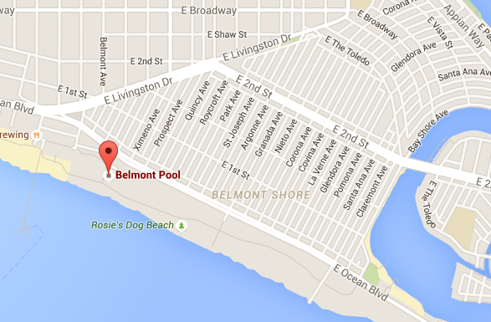
Yours in Scouting,
Alex Crenshaw

