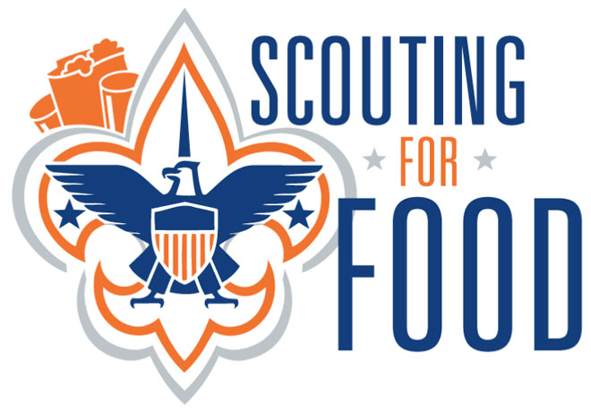
Long Beach Troop 212
Saturday 11/12/16 8:30 am – 11:30 am
We will be participating again in Long Beach Council’s Annual Scouting For Food
Non-Perishable (canned, jarred & boxed) Food Collection

Who: All Scouts.
We need a few parents to walk with each group of boys as well as a few parents to drive around and make food pick-ups from the boys.
We need all Scouts in town to help since some of the Troop is in DC!
When: Saturday, November 12, 2016
Time: 8:30 – 11:30 a.m.
We will meet at the church at 8:30 am for collection of permission slips & to pass out route maps and will head out around 9:00 am.
We expect it will take the boys approximately 2-3 hours to collect donations.
What to Wear: Full Class A Uniform
What to Bring: Permission Slip, a wagon or “granny cart” to carry food donations, bottled water or canteen, sunscreen.
Feel free to bring your own non-perishable food donations to add to our collection.
We will cover the area bordered by Carson to the north, Wardlow to the south, Gondar to the west and Los Coyotes to the east.
Questions: Call Frances Gawel at 562-310-3185 or email: francesgawel@verizon.net

