**Troop 212**

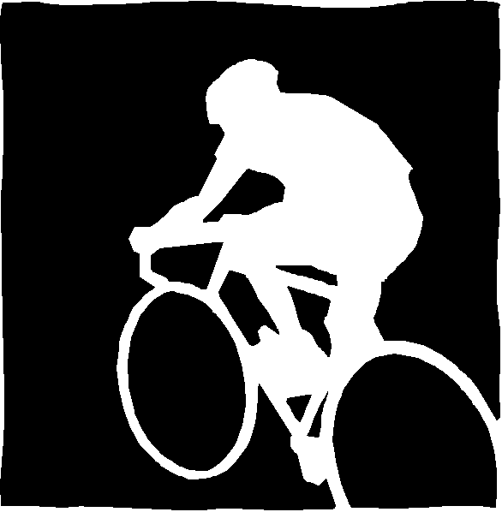

**100-Mile Bicycle Ride/Camp**

**Sat- Sun, February 25-26, 2017**

Dear Scouts and Scouters,

In the interest of Troop 212 being a High Adventure troop, we will be going on a 100-mile bike ride with a one night camp. The dates are Saturday, February 25th and 26th. The first day will be a 50 mile bike route that begins on Saturday at the church parking lot, riding along sidewalks to the San Gabriel River Trail, then down to and through Seal Beach, over the bridges on PCH, through Sunset Beach (not on PCH), then southeasterly along the Bolsa Chica/Huntington Beach bike trail, then northward up the Santa Ana River bike trail (SART). The bike riding ends at the Green River Golf Course in Corona where the riders will be driven 10 minutes to camp at Prado Regional Park. The trip resumes on Sunday when we will be transported back to the pick-up point from the day before and ride the 50 miles back to the church by reversing our path from Saturdays ride.

The bike ride is on mostly flat, moderately difficult (due to the distance), well established paved bike trials. There are some street intersection crossings between the church and the SGRT, a short stretch along streets in Seal Beach, and a short stretch on Pacific Coast Hwy just past Seal Beach on a marked bike lane. The Troop will regroup for lunch at Moon Park in Costa Mesa, approximately 28 miles from the church. Riders may summon a chase vehicle by cell phone anywhere along the ride or end their ride at any one of several check points established along the route. Check points at about every 10 miles will have water and snacks.

This outing can satisfy many Cycling merit badge requirements and give the scout an opportunity to complete the 50-mile, 8-hour ride requirement. All able bodied parents are welcome to join the ride. Participation in bike riding helps prepare scouts for many other Troop 212 high adventure activities. Scouts do not have to ride a bike to attend this outing as they may camp at Prado with the troop. Vehicles will be available to transport riders back to the church on Sunday if they are unable to ride the 50 mile second day route. Those that stick around and don’t ride back will break down camp and pack up. The Sat night and Sun morning meals for this trip are Troop feed with selected members of each patrol assisting in meal preparation and food shopping. There is no Thursday food shopping for the scouts. However there will be a bike safety check on Thursday night Feb 23. Riders will need to bring their bikes to the church that night to have them checked out.

The Troop will meet in the church parking lot Saturday, Feb 25th, 7am prepared to ride. Scouts should dress with layered clothing to peel off as they warm up (the early morning ride may be cold or wet this time of year). Scouts must bring all personal overnight camping gear to the church Saturday morning where a lead group of adults and non-biking scouts can haul it by vehicle to Prado. We will load up camping gear, conduct a pre-ride bike check, discuss the route, and review bike safety/contact information. Bike riders are anticipated to arrive at Green River Golf Course between 2-4pm where they’ll be driven to Prado. Class B uniforms only for this trip. Expect to arrive at the church around 2-4pm Sunday (depending on conditions and condition of riders!).

In order to participate on the ride, riders must have:

* A signed permission slip with $20/$10 (gas) due at Monday’s meeting of Feb 20th, 2017.
* A properly fitting bicycle helmet and a cell phone for emergency communications (mandatory!).
* A functioning bicycle preferably with changeable gears *(Road or hybrid bike style recommended).* Mountain bikes are okay but narrower street tires should be installed to reduce rolling resistance. BMX or beach cruiser style bicycles are not recommended. The bicycle must be in good working condition and have properly functioning brakes.
* Backpack or bike rack with bag lunch. Lunch on the ride Saturday is up to the rider to bring along with them. Lunch Sunday will be provided for the riders to carry with them.
* At least 70oz of water. Although water will be available during the trip, there may be stretches between water fill-up stations. Water bottles can be carried on a bicycle mounted bottle cage or in a day pack. A Camelbak type hydration daypack is ideal and can be useful to carry snacks, jackets and other listed items. ***Nothing can be carried in the rider’s hands!***
* Applied sunscreen, SPF 30 or greater.
* Layered clothing including an outer windbreaker or rain jacket.
* **Please note, ear inserted music listening devices are not allowed.**

Optional but highly recommended bike riding equipment is:

|  |  |
| --- | --- |
| * A tire tube repair kit with tire removers * A small portable tire hand pump * An extra padded bicycle seat cover * Biking shorts w/padded insert | * Riding gloves * Sunglasses |

**At a minimum**, the following items for camping should be packed:

|  |  |  |
| --- | --- | --- |
| * Appropriate clothing  **(Day 60s° Night in low 50s°)** * Change of socks and underwear * First Aid Kit * Flashlight * Ground Cloth * Hydration pack or Canteen | * Mess Kit (utensils, bowl, mug, etc.) * Pencil/Pen & Notebook * Pocket Knife * 10 foot Rope * Scout Handbook * Sleeping Bag and Pad * Change of clothes for ride back | * Shoes * Sunscreen and Chapstick * Toilet paper * Toothbrush & paste * Warm jacket * Whistle * Poncho |

Gate Code for afterhours Access at Prado Regional Park is 0745*

As is the tradition of all Troop 212 adventures, this will be a safe and fun outing, due in no small way to our adult support. If you have any questions, please call or e-mail Gary Brase, Kevin Coy or John Douglas.