**BOY SCOUT TROOP 212**

**FAMILY SKI DAY**

**At SNOW SUMMIT,**

**In Big Bear Lake, California**

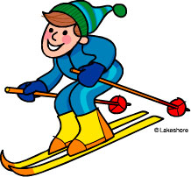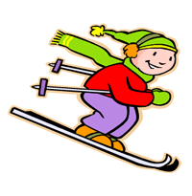

**SUNDAY, FEBRUARY 25, 2018**

**Mountain Hours: 9 a.m. – 4 p.m.**

**Equipment pickup starting at 7:30 a.m.**

Open to scouts, their families, and their friends

Ski instruction available by Snow Summit Ski School, if desired

John Douglas will also provide instruction

**This is a chance to earn your skiing merit badge. Merit badge class begins at 1:00 p.m.**

RSVPs, payments, permission slips and waivers due by Monday, February 12, 2018

NO late payments. Everything must be pre-paid. No refunds. Email to follow with ticket and rental of equipment prices and necessary forms.

**You need to pay the price with the TBID (new resort tax).**

This is a family event so we will not meet and caravan. Each family will drive on their own.

For information, call Frances Gawel at 562-310-3185 or email francesgawel@verizon.net