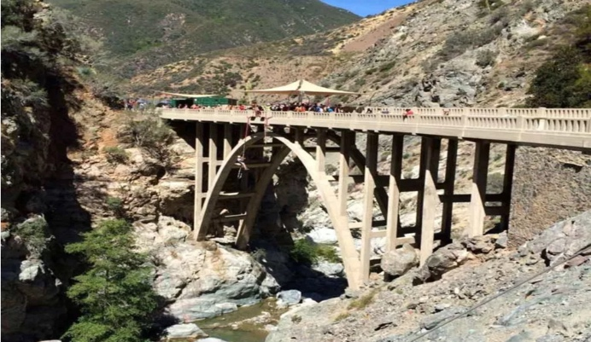
Troop 212 Conditioning Hike

Bridge to Nowhere

May 5th, 2018

Cost: The trip is free. If your scout is riding with another adult, please give the driver money for gas ($5 will do). Please bring a signed Troop Permission Slip to the church parking lot on Saturday May 5th. Drivers will need an Adventure Pass for parking at the trailhead. (Suggestion: 2 drivers jointly purchase the main and the “2nd Car” passes to save money. Passes can be purchased at Big 5, and other places)

Departure: Saturday, May 5th at 6:00 AM – Church parking lot. Please arrive promptly for a quick visual pack inspection and vehicle loading, then departure. Be sure to have filled canteens or hydration packs for the hike before you leave home. The trailhead is about 45 minutes from the church. We need an early start to beat the traffic and find a reasonable parking spot. Don’t be late! Drivers, we need to carpool as much as possible. Parking is terrible.

Return: Saturday, May 5th, at approximately 4:00 PM, back at Church Parking Lot.

The Bridge to Nowhere is a beautiful 1938 structure and, as its name suggests, is out in the middle of a canyon with no connecting road. Part of the 1930’s East Fork Road Project, torrential rain storms and floods washed out the newly constructed road leaving the bridge forever stranded. The hike is about 10-11 miles round-trip with a 900 ft. elevation gain. The trail crosses the river many times, so expect to walk through water. A walking staff is a useful aid to keep one’s balance when crossing. It’s suggested to alternate between wearing water socks and hiking boots or just plan to have wet hiking boots. Dry shoes and socks left in the car will be appreciated. The weather for the trip is expected to be 70-90 degrees and sunny. Please make sure you have a good breakfast, pack a bag lunch, and a bring a minimum of 3 liters of water.

This is a designated conditioning hike for the High Sierra backpacking trip in June. Scouts (and adults) planning to go in June are strongly encouraged to attend carrying the pack he intends to use on the High Sierra hike. This is your first chance to reacquaint yourself with old gear and become familiar with new gear. All other scouts (and adults) in the troop are welcome to join carrying small day packs. Depending upon attendance, two groups will be formed based on speed and experience.

Class B uniform is suggested, but not required...however, those in B's get extra points on the Rating Chart. This is an excellent chance to test out the NEW high-tech T212 T-Shirts! We will NOT be wearing class A uniforms on this trip.

As a minimum, the following items should be packed in a day pack (NO black duffel bags):

- Brim Hat (very important!)  - Sunscreen and Chap-stick  - First Aid Kit  - Pocket Knife  - 3 liters of water  - Flashlight (small is best) | - Bag lunch  - Small baggy of Handy-wipes  - Toilet paper & trowel  - Whistle  - Compass  - Walking Staff (troop has a few) | - Matches or Flint  - Pencils, Pens, Notebook  - Rope – 10 Feet  - Sunglasses  - Poncho/Rain Gear
If you have any questions, please contact Chuck Smith or the Jr. Leaders, Toby and Sebastian.

