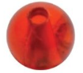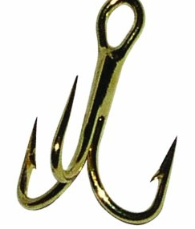

Optional small fishing bead, fish hate the sound of metal on metal, and this helps them from being scared away.



**Note:** *If you want to catch a fish, use a suggested rig, they work. If you do not, your chances of catching a fish decrease drastically.*

***Lake Fishing Rig***

Palomar Knot

Around size 14 snap swivel, if you use a regular swivel you will have to use the improved clinch knot



Small sliding sinker

2 or 4 pound leader

4 or 6 pound line

Palomar Knots

The Palomar knot is one of the easiest and sturdy knots in fishing. When tying it to the snap-swivel, you will have to unsnap it to put the loop through, and then re-snap it when you are done tying the knot.

About size 14 treble hook

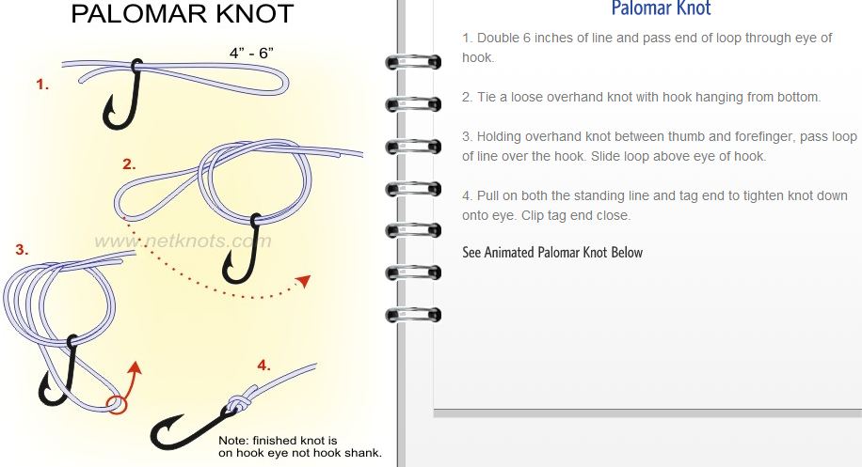

Bait:

1. Use 2/3 of a night crawler and a dough (the cut night crawler lets out a bloody sent to the fishes)
2. A fake mice tail and a dough
3. Just a dough
4. Local bugs the fish are eating

*created by Dominic Gawel