BSA TROOP 212

COLORADO RIVER CANOE TRIP

From Hoover Dam
TO
COTTONWOOD COVE MARINA

December 2023
( Published 10-5-23)

NOTE 1: This booklet has more information than the version sent out a few days ago. What has changed is the addition of more safety procedure information, and more training information.

NOTE 2: In addition, we have added more paddling practice time during our training sessions.

NOTE 3, DATE TO REMEMBER: All reservations require a $50 deposit per person collected on Monday, November 6th Seating is limited to 28 people this year.

NOTE 4, DATE TO REMEMBER: The balance of $445 is due any time by or before December 11th

NOTE 5: DATE TO REMEMBER: The 3 forms found at the end of this booklet are due to Scoutmaster by or before December 11th.

.NOTE 6: We will be conducting THREE SAFETY PRACTICE SESSIONS on Saturday Oct 28, Saturday Dec 2nd , and Saturday, Dec 16, at the Sea Scout Base, at a cost of $15.00 per person, per session, beginning at 8:00 AM for check in, to include money and permission slips collection

BSA TROOP 212 ~ COLORADO RIVER CANOE TRIP ~ WINTER OF 2023

As you know, the Troop will canoe the Colorado River this December, departing form Black Canyon, which is the base of Hoover Dam, during the holiday school break. Properly qualified Scouts and Scouters' of our troop, Alumni and present Troop members, are welcome to take part in this river adventure. This booklet is the Guide for that trip. If you have any questions, please feel free to contact the Trip Leader, Scoutmaster John Douglas 310-628-4312(c). Please review the section entitled

DEPARTURE & RETURN MEETING PLACE & TIME?
We will meet at the Church parking lot at 7:30 AM, with plans to depart at 8:00 AM on December 26th. We will canoe early morning from the base of Hoover Dam on canoe day #1, the 27th, for 3 full days on the River, We will return to the same church parking lot on December 30th, about 4:00 PM. Updates on our return arrival time will be available by checking SPOT on our Website main page, OR my cell phone. Please be aware and patient with the cell service which is intermittent in various parts of the state as we travel home.

QUALIFICATIONS TO GO?
Anyone who is a BSA registered Scouter or active Scout with Troop 212 may come along. Alumni of the Troop are also encouraged to participate as well. In addition, we require each participant to have as a minimum, pass the Summer Camp level swimming requirement, or the equivalent, as approved by the Scoutmaster. For the safety of all participants, we reserve the right to administer our own swim test prior to trip confirmation.

WEATHER?
December days at about mid 60 degrees or slightly higher, windy, and a bit cooler at night, at about 30 degrees. Last time we did this adventure it dropped, uncharacteristically to only 40 degrees at night, and a few years before to 28 degrees. SO…BE PREPERED this year for both conditions.

IS IT SAFE?
Fast water does not typically exist on this river adventure. However, the river can be quite challenging in several places, even some white caps, and very choppy current, depending on Hoover Dam water release schedules and high winds, which can make paddling difficult… especially when we cross open water. Don't worry, we'll show you how to stay safe. For the record, we expect not to exceed class II water for most of the way, which is considered MODERATE: larger waves, but no obstacles or obstructions. We will be using full sized, expedition level, aluminum canoes from a new to the troop, but very experienced, River Certified vendor; Jerkwater Canoe. He has a few operating changes that are different from the previous vendor, which will be reviewed during our practice training sessions.

Due to global warming, we have learned the weather can be quite unpredictable. On some days the River water can be slow and boring, while other days high winds can cause particularly hoppy waves, and slow down a canoe team’s forward progress. If these rougher days occur, we will be stopping at several resting beaches along the way, and gathering all participants to check how each canoe team is performing. Depending on conditions, we may rest longer, or maybe stop for the day, and pitch beach camp sooner to get off the water. We have added an additional powered safety boat this year to the program and will be in touch with the Parks and Recreation Ranger Services along the way as well.

COSTS, RESERVATION DEPOSITS, FINAL PAYMENTS, PERMISSION SLIPS, AND CANCELLATIONS?
The cost of this 5 day adventure, with 3 days on the River, will be an estimated $495.00 per person to cover the cost of River prepped food for three days , two nights camping on the beach, souvenir patches, comfortable hotel stay the first night, with great restaurant super that night and restaurant breakfast the next day, Dam Launch Permit, safety boat fuel, vehicle parking and transport fees, rentals of canoes, paddles, life jackets, final night hotel room with hot showers, final night restaurant hearty supper and restaurant breakfast the next day. For the two nights camping on the first beach, near Willow Beach Marina, is near a Parks and Recreation bathroom, and for the other beach (no name) we will be using a troop owned, self-contained, porta potty.

We believe this to be a reliable cost estimate, based on participant counts in the past, and we will do everything possible to drive this cost lower if possible. Any changes to the final price will be determined later based on the actual number of participants and any volume discounts we are able to secure along the way.

All RESERVATIONS require a $50 DEPOSIT which will be collected on Monday, November 6th and will be used to secure the various reservations required for this adventure.

Deposit payments ensure we will have a place for you because we are limiting this event to 14 canoes, which is 28 participants, due to the limited of the number of Hoover Dam Launch Permits allowed. Please be aware that trip deposits are treated as a “commitment to attend” and are forwarded to our equipment vendor with that commitment in mind. The balance of $445 is due any time by or before December 11th. There will be a 15 % additional fee on payments received after the 11th. The troop standard permission slip and canoe vendor permission slip will be collected by that day as well. Blank forms at attached as the last two pages of this booklet .
All BSA Medical Forms, if we do not have them currently on file, and 1 Troop Permission Slip per scout, and 1 Canoe Vendor Rental Agreement per person, will be collected on Monday, December 11 th, or sooner if you have them. Copies of these blank forms will be available on our web page. If these payments, and all required forms, are not received by deadline, this may be treated as an automatic cancellation, with a probable loss of deposit monies. That subsequent open spot will be filled by one of the waiting on “Stand by List” folks.

All checks should be payable to "BSA Troop 212". Sorry, but any bounced checks will be treated as an automatic cancellation. If you need to request a cancellation/refund, we can only return to you any un-expended funds we have not submitted/committed on your behalf to our vendors, so be sure by the deposit deadline that you are serious about attending this High Adventure on the Colorado River.

EXTRA SPENDING MONEY?
Extra spending money needs for the participants has been kept to a minimum because MOST meals will be prepared troop style on the River as part of the trip, and while staying at the hotel and marina. However, the first travel day plan on bringing a bag lunch and drink for the road side picnic area we traditionally use, and the last day traveling home, plan on one fast food restaurant lunch. All road traveling meals or snacks are NOT included in the above estimated cost of this trip. Travel fuel costs are also not part of this estimate. Individuals need to work this out with the drivers directly during the actual trip. Carpooling is encouraged to save on fuel costs. .

TRAVEL MAPS?
Maps for road travel will be found on the troop web site prior to departure.

RIVER MAPS?
River maps may be handed out during training meetings, AND at the Trip Briefing Update Session on December 26th at 7 PM at the hotel.

RISK?
This trip is not for everyone. River expeditions are fun, exciting, rambunctious, and occasionally tough to control. To join us in the fun, you must be in good health, free of heart conditions, back problems and other physical conditions which could be aggravated by this adventure. All participants must understand that there are inherent risks in any outdoor sport such as river canoeing. Accident and illness can happen. Each participant must be in good physical condition capable of this level of physical activity. We will be exploring a still undeveloped part of the River, so any rescue professionals we may require will far away. So for that reason, group safety will be our primary consideration in all decisions, and we urge only individuals that enjoy outdoor challenges participate.

COVID POLICY AND PROCEDURES?
We expect everyone on the adventure, as in all in Scouting adventures, to follow the measures listed below, which are based on CDC guidance. We must also follow all federal, state, local, tribal, and territorial rules and regulations, including local business and workplace guidance of the locations we will be visiting. Isolate if you are sick, and do not attend any activity/meeting/event if you, anyone you live with, or anyone you have recently been around feels unwell.
- Do not attend any activity/meeting/event if you or anyone you live with has been tested for COVID-19 or another illness and does not have the results back yet.
- If you are not fully vaccinated, wear a face covering or mask that covers your nose and mouth and stay at least 6 feet apart from people you don’t live with.
- Wash your hands often with soap and water. Use hand sanitizer if soap and water are not available.
- As always, please exhibit the Scout Oath and Law as we continue to navigate a safe return to the activities we enjoy.

Camping will take place in accordance with guidelines outlined by our state and local health department and other local officials. There is no formal national scouting policy on social distancing in tents, just as there is no prohibition on tenting alone if logistics can accommodate that request. As always, all BSA youth protection policies must be followed. For this adventure we plan on keeping room partners, canoe partners and tenting partners the same throughout, as best as we are able. All prices are based on double occupancies, so any demands for single accommodations can be met, if possible, and may have a higher trip cost associated with them.
We also encourage anyone whose medical condition or history has changed significantly since their last physical exam to get approval from their health care provider prior to attending this adventure. Immersion into cold River water is a possibility. We will teaching the proper safety procedures, in the event this were to happen, during our canoeing practice sessions.
Scouter Code of Conduct and relevant program safety and training requirements are still in place, e.g., Safe Swim Defense, Hazardous Weather, Wilderness First Aid, etc.
RESPONSIBILITY?
We reserve the right to cancel or make changes in itinerary or river section. This might happen if it were deemed advisable for the comfort and well being of canoeists and/or were necessary due to insufficient water levels, bad weather, sickness or other factors beyond control. In circumstances which our organization has no control, we accept and assume no responsibility whatever for any damages, injuries, losses or delays, whether to person or property.

BAGGAGE?
Ideally, for greater ease and comfort, all personal belongings, including your sleeping bag, should fit in one duffle bag, not to exceed 18" in diameter, with your name on it. But, if you must, a second, small bag, or day pack bag, for your essentials will be OK. Just make sure all bags are properly packed (water proofed), name tagged and tethered to the canoe.

WHAT TO BRING?
We want you to "be prepared" for all kinds of weather. However, please try to hold your baggage weight down. It might be helpful if you keep in mind you are carrying your own bag(s) from the canoe docking area pack line to the campsite at the end of each day, as well as bringing it back to the canoe docking area pack line the next chilly morning. EVERYTHING YOU BRING MUST HAVE YOUR NAME AND CANOE NUMBER ON IT. Bring only the items you really need, which, as a minimum, should include:

SLEEPING BAG.............................. (Be prepared for warm AND cold nights)
WATER-PROOF RAIN SUIT........... (Good 2 piece suit. Important!)
AIR MATTRESS OR FOAM PAD.... (Watch bulk problems of these)
SOCKS, WARM WOOL................... (For Camp shoes use)
HAT, WIDE BRIM TYPE................. (For day use)
WOOL CAP AND SCARF ..........… (for cold evening s)
WARM SWEATER….............................…(for cold evening s).
WARM OUTER COAT…...................……(for cold evening s)
TENNIS SHOES.................................... (For WET use in canoe)
CAMP SHOES....................................... (For DRY use at each camp site)
LONG PANTS....................................... (2 pairs SUGGESTED)
SUNGLASSES ......................................(Necessary to you)
OTHER PERSONALS.......................... (Necessary to you)
BAND AIDS & MEDS.......................... (Personal first aid supplies)
WASH KIT & TOWEL........................... (And soap, hair brush, etc, can be stored with uniform)
TOILET PAPER & SMALL SHOVEL.... (For emergencies, in separate plastic bags)
ROPE CUT IN 10 FT LENGTHS......... (5 pcs, MINIMUM, for all gear tie down & canoe docking)
FLASH LIGHT...................................... (Extra batteries also)
CANTEEN............................................ (Small plastic is best)
CAMERA AND SPARE BATTERY...... (In waterproof container)
GLOVES & KNEE PADS..................... (May be needed when paddling)
SUN BLOCK OUT............................... (Even for those that "don't burn"!)
PERSONAL BOWL, PLATE, MUG, & EATING UTENCILS.... (Must have name on them. Please note, the eating utensil will be used every meal, and washed.)
BAILER ON ROPE W/ SPONGE tied together w/ a min. 4 ft string ................(Must have name on it)

The above suggestion list may not be complete. You should complete it based on your personal needs/desires. If you are unsure about what to bring, please phone the Trip Leader.

THE BEST WAY TO PACK?
First, don't panic. It's easy, it's simple, and it’s inexpensive. PAY ATTENTION HERE: Nothing--absolutely nothing-- beats an old fashioned DUFFLE BAG, GI style canvas, zipper style, nylon or cotton. We strongly recommend one duffle bag per person AND one small essentials bag is allowed for under the seat. BOTH need to be tied/tethered to the canoe and BOTH with your name on the bag.

For your sleeping bag, line the inside of a stuff bag with a heavy duty trash bag -- NOT the outside, the INSIDE. Thens tuff your sleeping bag inside. This goes in your large black duffle.

Next pack your clothes, toilet articles, cameras, etc. in Zip-Loc type bags, large and small. Place all of these in one or two larger nylon bags, or even an old pillow case, to protect the plastic bags from ripping and these go into your duffle. That's it! A few extra plastic bags for later use can be put on bottom for good measure. NOTHING SHOULD HAVE PLASTIC BAGS ON THE OUTSIDE, THEY WILL RIP IMMEDIATELY!

We want you to bring everything you need to make your trip pleasurable. BUT trucks, vans, trailers and canoes have only so much space and cannot be stretched. If these bags are too large, they will not fit in the canoes. Our troop standard sized black duffle bags that are used for every other trip should work fine for your needs on this canoe trip. AND a canoe full of loose gear is an accident waiting to happen. Duffle bags and canoes were made for each other. Backpacks are great for backpacking, but framed packs DO NOT work in canoes. Frames WILL BE DAMAGED, so leave them home.

UNIFORM?
As always, full BSA uniforms will be worn during automobile travel time on BOTH travel days. Uniforms will be stored in our vehicles while on the River to ensure that they are kept neat & dry for when we exit the river. Scout Class "B" T-shirts are encouraged, and should be worn while on the river and at river campsites.

MENU?
This trip we will be preparing a blending of dehydrated meals, canned foods, and frozen foods, using transportable propane stoves, and troop cooking pots. Each canoe will be assigned a LARGE gray plastic tub containing the River food and some kitchen equipment for preparing this food. Each canoe will also be assigned one or two pieces of other troop gear they are to keep track of and make available every evening at camp as well as pack up in the mornings. Examples of this might be the troop first aid kit, troop axe, troop saw, or troop rope for securing canoes, lanterns, propane, and a few roll up tables. Lunches on the River will be a prepared on your own in either a central beach lunch area, or in your canoe while traveling, depending on water and weather conditions or beach landing availability. River supper and breakfast meals will be prepared “all canoe teams” style, in a central kitchen area on each beach we camp on.

MEAL TIMES?
We plan on breakfast at about 7AM while on the River, and at the Marina and hotel. The lunch time target is 12 noon, but is dependent of beach side availability or “rafting up” arrangements. We plan on having supper by or before 4:30 PM, to allow for ample clean up time, an evening campfire, and a good night’s sleep.
This supper goal will be accomplished if we can locate an acceptable beach side camping area by 3 PM that day.

PERSONAL UTENSILS?
You will need your own reusable hot drink mugs, breakfast bowls, spoons and forks for each meal. Trip participants will be responsible for the proper cleaning of their own personal utensils...basins with wash water will be provided in the kitchen area. The group breakfast/supper preparation pots and serving utensils will be washed out by the various food prep Canoe teams.

DRINKING WATER/
We do not filter the River water for any consumption or washing use. Each Canoe Team will be assigned 2 five-gallon water jugs for the full trip for group use.

GARBAGE?
We carry out everything we bring on the river. This would include magazines, tin cans, bottles, raincoats, etc. Everything you bring in must be taken out. We will only burn our paper garbage while on the river during our evening campfires. Each canoe will be responsible for its own trash management.

FOLDING CHAIRS?
These chairs are only acceptable if they are small light weight, easy to fold & transport, as well as easy to pack in the canoe. For safety, we do not plan on using these chairs to sit in the canoes. They are for camp use only.

TENTS AND OTHER GEAR TROOP PROVIDED?
As you can see from the Personal List above in this booklet, most of you will not need to bring your own tent. We have enough TWO man tents for most the canoes going on this adventure. If any of you would feel more comfortable using your own tents, please let the Trip Leader know at least 3 weeks before trip departure.

MEDICINES?
Use of any prescription drugs need to be clearly explained to the Scoutmaster or his authorized assistant to trip departure. (Same process as Summer Camp.)

BSA MEDICAL HEALTH FORMS REQUIRED?
If you have attended our most recent Summer Camp with the properly completed Health Forms, you are probably covered for this River trip. Please confirm this with Terrie Haynes.

For all other trip participants, we suggest they schedule their appointment with their health care provider for a physical exam soonest possible, and bring the new Annual Health and Medical Record Form (Rev 2/2011) Part A, B, and C which is available under Resource/Forms on our troop website www.troop212.net/resources/forms (print pages 1-4). These completed forms will be due when final payments are collected Monday, December 5th, and will be collect by Dana S.

In order to fulfill this requirement completely, please remember;
- Part A, B, C required ( For participants in any event that exceeds 72 consecutive hours, all high adventure base participants, or when the nature of the activity is strenuous and demanding)
- Make sure immunization section is complete (Part A).
- Make sure to get the Signature of the health care provider on Part A, under the medication section, and on Part C.
- Attach a copy of the medical insurance card, front and back.
- All Scout/Adult signatures on Part B

CANOE PAIRS/TEAMS ON THE RIVER?
Trip participants with requests to be matched and paired in the same canoe with their buddy will be honored, as long these requests are registered with the Trip Leader in a timely manner. However, the Trip Leader may need to modify these requests based on observed canoeing abilities, food preparation skills, and weight balancing requirements.

PRE-TRIP PREPARATIONS?
Long before this river adventure begins, detailed preparations need to be made well in advance. These include such things as food planning, food shopping, equipment readiness, prepackaging of food boxes, and vehicle loading. We will meet at the Scoutmasters house (Alley way in the back of 5723 Bonfair Ave, Lakewood) on Sunday, December 17 at 12:00 PM, to prepare troop gear and food boxes required for the trip.

DAILY OPERATIONS?
While on this river adventure, each canoeing pair (AKA Canoe Teams) will be responsible for their own canoe and related safety gear. Each canoe will have in it the personal gear of its occupants, the single dome tent assigned to those occupants, and their share of troop gear stored in a single gray plastic box, and two 5 gallon water jugs. Some canoes may the roll up tables or propane tanks. Each team will be responsible for their own tent set up and lunch on the river. The breakfast/suppers will be a group feed, prepared in a central location, easily accessible for all participants.

DOCKING AND TIE UP PROCEDURES?
Whenever we dock on a beach for lunch, stretch break, or overnight camp, we need to be mindful of rising water levels that may draw our canoes back into open water. To prevent this, we all need to pull our canoes fully onto the beach, and sometimes tied to each other, then anchored to a non floating location.

SOUVENIR PATCHES?
A custom designed, canoeing souvenir patch, will be issued to those that complete the river run.

CANOEING MERIT BADGE?
Scouts may be eligible to earn the Canoeing Merit Badge. If, after reading the M. B. requirements, you wish to work for this badge during this trip, you must inform the Trip Leader (who is also the M.B. Counselor) before December 25th.

RADIO COMMUNICATIONS?
As usual, we will be using the troop FM HAM radios during our road travel time. These units will used on the River as well. All adults that are assigned these for auto travel need to bring them along for River travel as well.

PROPER ID’S?
Please note that Hoover Dam security will ask everyone 18 years old and older to present their driver lisc for examination. Please remember to keep them handy, and NOT pack them in your canoe bags until we are actually by the Launch Site at the bottom of Hoover Dam

LONG BEACH CANOEING SAFETY PRACTICE SESSIONS

We will be conducting THREE SAFETY PRACTICE SESSIONS Saturday Oct 28, Saturday Dec 2nd , and Saturday, Dec 16, AT THE SCOUT SEA BASE, at a cost of $15.00 per person, beginning at 8:00 AM for check in, to include money and permission slips collection.. Please remember to wear the cloths you plan on getting wet in, as well as bring along a dry change of clothes for later. A water bottle and a snack are also suggested.

We have a great deal of information to go over during these sessions, so after check in, we will begin promptly at 8:30 AM am with the Ground School portion of the program. After that , we will be pulling canoes from the racks, and launch for the Float Control portion of the program. The day should end just after 12 noon.

Experience has taught us missing any of these safety sessions may cause you to miss an important skill or safety procedure that could affect your ability, or someone else's, to have fun and be safe on this trip, so full participation at all safety sessions is strongly encouraged . Any of our Troop 212 Scouts or Scouters may attend these sessions even if they do not plan to go on the week long December River trip just for fun, or to earn the Canoeing MB. The Scoutmaster is the MB Counselor.

We will collect the ONE permission slip for each of these practice dates, since these are used to log in payments received, and other credits. This standard troop 212 version permission slip, see attached, and fees per session, collected efficiently that morning at 8:00 AM, should not sacrifice any of our session time, which begins promptly at 8:30 AM . Please remember to arrive in clothes and shoes that are able to get wet, because you will be dunking the canoes, probably swimming in your cloths, and wading in the water to enter the canoes. All participants are expected to perform their fair share of proper canoe clean up and storage before leaving for home. Feel free to bring your own paddle if you wish. Please don't forget towels, canteen, and sunscreen, as well as spare dry clothes for the trip home.

The scope of the three safety sessions days will be different each day. To ensure each participant is properly prepared to enjoy this adventure, and to be safe doing so, Day 1 covers much basic canoe safety process, and ends with an hour of paddling time. Day 2 has one hour ground work, and two hours paddling time. Day 3 has three hours paddling time.

The outline of these sessions is shown below. To ensure a fun and safe event, participants will be required to be fully aware of the procedures, policies and general safety information presented during these sessions. Not attending any of these practice sessions does not absolve the participant of this responsibility.

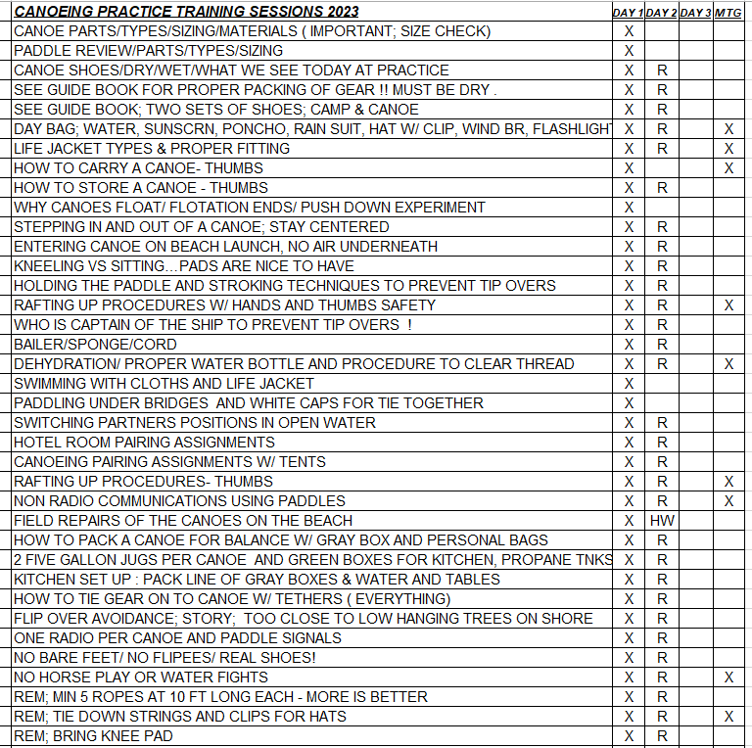

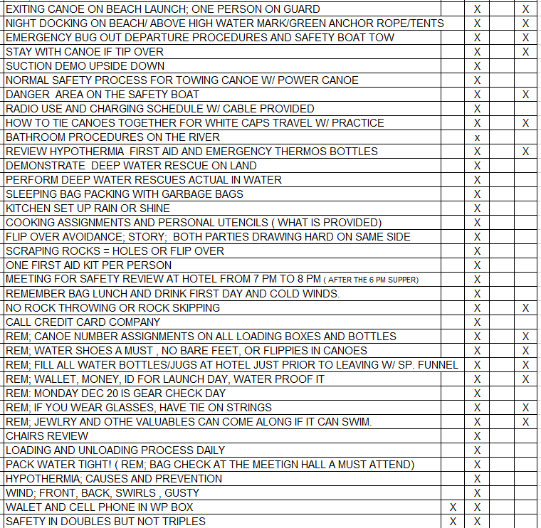

GEAR PACKING & GEAR CHECK MEETING?
In a way, the trip begins before we depart from the Church parking lot on the 26th. We say this because on the Monday December 18th Troop Meeting, we will all meet in the usual location, with our fully packed bags of gear for gear check. PLEASE use the gear list above a guide for what items we will be expecting each participant to show us during gear check. Any additional canoe trip questions or last minute announcements or changes about the trip will also be taken care of at this meeting. After this meeting, all personal equipment bags may be brought back home for any corrective action. We have noticed over the years that not following the gear list almost guarantees a miserable River experience.

TRIP ITINERARY
The first day, December 26th, we will travel, in uniform, to the Colorado River, Cottonwood Cove and Marina Camp Ground, . Along the way we will stop in Barstow for fuel, and later in a road side rest area in Nipton to have the bag lunches/drinks you all have brought from home. When we arrive at Cottonwood Cove, at about 2 PM, all participants will change out of their uniforms and into Class B play cloths and transfer all gear to the Canoe Support Vans. The plan is to store uniforms in the parked cars to ensure they are clean, and dry for the return drive home. All vehicles (park them facing OUT for easier departure later) will remain at Cottonwood Cove Marina. We will depart at about 3 PM and proceed about two more hours by Canoe Support Vans, wearing Covid prevention masks, to our launch location Hotel near Hoover Dam ( the Hoover Dam Lodge), arriving at about 5 PM. Since we will be tired from the drive, we will plan on having a 6:00 PM supper at the hotel, and after a 7 PM Safety Review Meeting, go to bed early, to ensure plenty of rest for the rigorous days ahead.

The next day, the 27th, will be Team 1's first canoeing day. We wake up early enough to attend the 6:00 AM breakfast at the hotel restaurant. Participants will be responsible for packing up their personal belongings in their bags (ready for canoeing), filling up their personal canteens and troop owned five gallon jugs, and getting all gear packed in trailers/vehicles for the Launch Check In of 7:00 AM above the Dam for our 8 AM launch time. We will be given only 45 of the 60 minutes allotted to us to actually load/launch the canoes by the waters edge, so we will stop/meet at the first nearby gravel beach, about 300 feet down river on the right, for proper re-loading, re-balancing. ( See CANOE LOADING below for more details) Later in the day, the first, and pretty much the last, civil bathroom will be found at Willow Beach Marina much later in the day…stop for a break and use the snack shop as well. We will camp at a local palm tree park on the left side of the River, just 100 yards downstream from the Marina, OR we will camp about 2 miles downstream from the Marina, on the right side. This beach camping destination is an open beach area about 12 to 14 miles downstream from our original Dam based launch point. This camp site will have NO facilities. When we all arrive at this camp everyone needs to make sure all canoes, life jackets and paddles are secured inside the canoes. We will be on the River all day, occasionally stopping along the way for a beach side lunch and stretch breaks. The plan is to have all the canoes off the River by 3:00 PM, have supper by 4:00 PM, and clean up completed by 5:00 PM, as it begins to get dark and colder. Most of the day you will be at the bottom of some very high Cliffs, a familiar site when traveling thru canyons of this type.

The next day, the 28th, first thing that morning, like every morning, participants will be responsible for packing up their personal belongings, filling up their canteens from their 5 gallon water jugs, and getting all personal and troop gear into their canoe. By now everyone should be familiar with the required routines for cooking and packing. After a warm breakfast at about 7:00 AM, again, with a quick and early departure, we will be canoeing a bit further today for about 18 miles this day. Lunch will be either a raft up type or a beach side type, depending on conditions. Also depending on conditions, we believe our camping destination will be an open beach camping area again, located just upstream from the large overhead power lines crossing the River. This camp will not have any facilities, and we have picked the best spot that can handle a group of our size. The plan is to have all the canoes off the River by 3:00 PM, have supper by 4:00 PM, and clean up completed by 5:00 PM, as it begins to get dark and colder. Most of the day you will be in very open areas enjoying long vistas, with cliffs on our left and majestic open beaches on our right.

The next day, the 29th, will be our third and final day of canoeing. Breakfast will be at about 7:00 AM, again, and we need to perform the usual morning routine to get on the water. This day may be quite windy. We will be on the River for a relatively short time in the morning when you will notice it opens up wide and looks like a lake instead of a river. Often at this time high winds become more apparent, so we will travel down the safest side of the water way, depending on conditions, which is often the left side. We will stop to get out of the wind on the left side later that day. The mile marker and flashing light used to determine that left turn will be announced at breakfast. This part of the trip is where the Long Beach practice sessions really pay off if we observe white cap water. Some years this portion of the trip has had no wind. We are traveling only 11 miles this day, and we are looking for Cottonwood campground, on the right side. In fact, the plan is to have all the canoes off the River by about 4:00 PM, even if there is wind, unload our personal gear, check in at the Cotton wood Marina Hotel, shower, and depart the marina, in uniform, at 6 PM for our supper reservation at 6:30 PM in the town of Searchlight, NV.

The next day, the 30th, we awake early enough to pack up and depart the marina at 7:30 AM, ( we will not be returning that day to the marina) for breakfast reservation at 8 AM in town. At about 9 AM we depart for home..

About three hours later (12:00 noon ?) we will be stopping in Barstow for lunch. You should have your lunch money in your pockets, and NOT in the packed duffle bags. Later that day, along the way home, we WILL stop for rest breaks as needed. Our estimated time of arrival to the Church parking lot is about 3 PM. Updates on our return arrival time will be available by checking SPOT on our Website, by clicking the SPOT logo is on the troop’s Home Page, OR my cell phone is 310-628-4312.

CANOE LOADING WHILE ON THE WATER?
There are two objectives here, one is to pack efficiently so that the gear isn't sitting too high above the gunwales, and the other is to balance out the canoe so it doesn't list to one side. In addition, placing the heaviest items where they will have the best positive impact on your balance and maneuverability is best. In canoeing, this equates to packing the heavy gear on the bottom and in the center of the vessel. Medium-heavy items can be placed over heavier gear, and lighter items can be placed at the far ends of the canoe. This tactic will keep the canoe balanced and properly trimmed. It's likely you may need to shift some weight around once paddlers are in as well, but for the most part, the strategy of centering the majority of the weight is a common practice. Once you have it packed, you'll want to develop some system of tying everything into the canoe. A criss-crossing of ropes works well with the troop boxes, and a single tether line works well for the personal gear bags.

OTHER IMPORTANT & HELPFUL TIPS?

- If you wear glasses, be sure to have tie-on strings for them to prevent lose.

- Jewelry, rings, and other valuables should not be taken along on this trip. If it can't swim, don't take it.

Extra spending money needs for the participants has been kept to a minimum because most of the meals will be prepared Canoe Team style as part of the trip.

- Although canoe paddles will be provided by the canoe rental company, several experienced Troop 212 canoeists bring their own. This is certainly encouraged, but we are still responsible for all the rented paddles, even if we don't use them. Therefore, these rented "extra" paddles will be kept with the canoes for "emergency" purposes. We also suggest that the owners name be placed somewhere on the personal paddles.

- Each participant should bring their own bailer (with their name on it) and sponge, tied together by a 4 foot nylon cord, as demonstrated. Buy a package of 100 ft extra cord, and pre-cut these into ten pcs of 10 ft sections, in order to tie down the gear in the canoes. In addition, we would each canoe team to have a Canoe Repair Kit. We will show you how to create one of these repair kits during the training sessions.

- Sunscreen applied very, very often and wide brim hats with chin straps or safety tethers.

WHAT IS THE MEAL PLAN FO RTHIS TRIP ?

CANOE-MENU- FOR 2023 | BREAKFAST MEAL | LUNCH MEAL | SUPPER MEAL
DEC 26/ (DAY #1) | HOME | PERSONAL BAG F/ HOME | AT RESTAURANT
DEC 27/ (DAY #2) | AT RESTAURANT | Chicken & Crackers Lunch Kit | Chile Fetchini
 |  | Apple Sauce Fruit Cups | Rolls
 |  | Granolla Bars | Punch Drink
 |  | Candy | Hot Choc/ Coffee
 |  | Cookies | DESERT
DEC 28/ (DAY #3) | Scr. Eggs w/ bacon bits | Chicken & Crackers Lunch Kit | Beef Stew w/ Veggies
 | Tortilla & Salsa | Apple Sauce Fruit Cups | with Mashed Potatoes
 | Coffee Cakes | Granolla Bars | Rolls
 | Hot Choc/ Coffee | Candy | Punch Drink
 | Hot Cereal | Cookies | Hot Choc/ Coffee
 | Fruit Cups |  | DESERT
 | Granolla Bars
DEC 29/ (DAY #4) | Scr. Eggs w/ bacon bits | Chicken & Crackers Lunch Kit | RESTAURANT
 | Tortilla & Salsa | Apple Sauce Fruit Cups
 | Hot Choc/ Coffee | Granolla Bars
 | Hot Cereal | Candy
 | Fruit Cups | Cookies
 | Coffee Cakes
 | Granolla Bars
 | NOTE1; ALL LUNCH MATERIAL EVENLY DIVIDED TO ALL CANOES.
 | NOTE2; ALL CANOES CAN EAT LUNCHES AT ANY TIME.

BLACK CANYON TRIP OFFICIAL RULES;

Leave No Trace: Black Canyon is designated as a wilderness area. When visiting, you should leave no trace of your passing through. Anything packed in must be packed out. All trash, human waste, and ashes from campfires or charcoal fires must be taken out with you. There are dumpsters located at the end of the trip.

Please do not interact with any wildlife you might encounter. It is great to observe, but, feeding, chasing, or annoying the wildlife is not allowed.

Geological features are not to be altered in any way, i.e. no graffiti or toppling of any rock formations.

Fire Regulations: 1. Fire size must be less than three feet in diameter. 2. Fire must be at least ten feet from the nearest beach logs, structures, or vegetation. 3. Chemically treated wood, painted wood, or wood with nails or staples shall not be used. 4. Fires must be above ground (no pit fires) and attended at all times. 5. Fires must be completely extinguished with water: doused and stirred. Fires should not be covered with sand; as it will insulate the heat and create an unseen danger for wildlife and visitors. 6. Rock rings must be deconstructed and refuse must be removed after visit. 7. Debris burning is not permitted. 8. When shoreline camping, all charcoal ashes must be packed out and disposed of in park trash receptacles after ensuring that they are completely extinguished. 9. Gathering of firewood and brush for burning is prohibited.

Recommended Items: 1. Typical camping gear, but only bring what you will utilize. Too much is just as bad as too little – there is limited space in the canoes, and very limited time for the launch. 2. Waterproof bag(s). Lining a duffel bag with a plastic bag is a suitable alternative. However, a plastic bag alone will likely rip a hole before ever making it into the paddle craft. 3. Plenty of drinking water. Water is heavy takes up quite a bit of space. 4. Portable toilet. Toilet facilities are limited. A bucket with toilet seat lid that utilizes disposable waste bags works quite well. 5. Coolers not exceeding 35 inches at the widest point; larger coolers will not sit down inside the boat. 6. Hats, gloves, binoculars, sunscreen, and insect repellant.

Prohibited Items/Activities: The following items and activities are prohibited anywhere in the canyon. 1. Glass, Styrofoam, Drones of any kind, inflatable and non-inflatable pool toys. a. Violators are subject to a $5,000.00 fine 2. Do not climb on or around the catwalk located near Willow Beach. It is very old and very dangerous. 3. Cliff diving is not allowed.

END

NOTE: The 3 forms below
are due to the Scoutmaster by or before
December 11th, 2023.

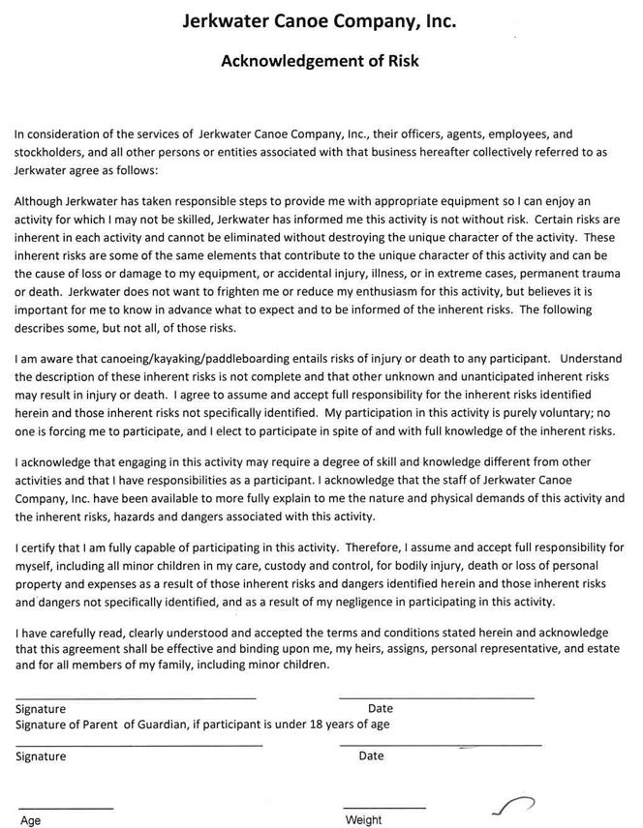

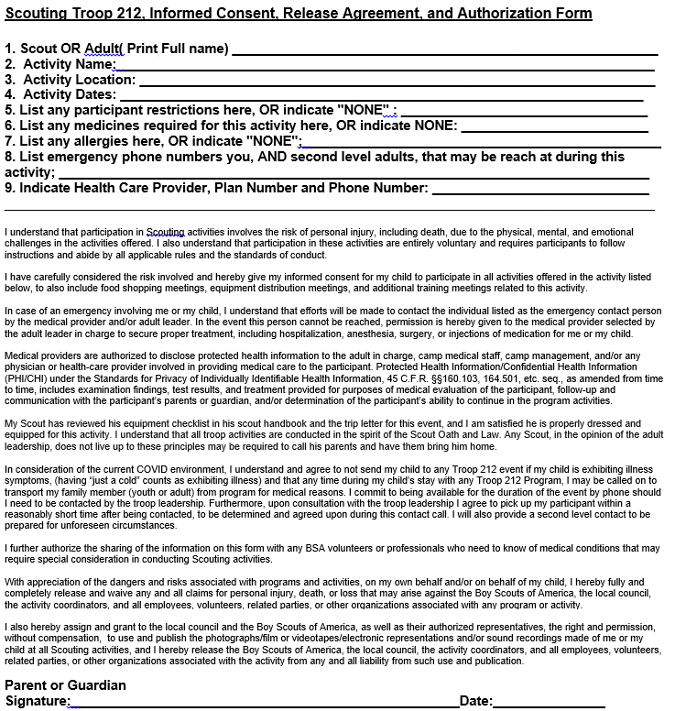

Date: _
2021 ADULT MEDICAL INFORMATION FORM

Print Name:________________________ Signature:______________________
Print Event Name and Dates:___________________________________________

Please answer yes or no
I currently have: List medications you currently use;
If none, write none
_____ Asthma _______________________________
_____ Diabetes _______________________________
_____ Convulsions or epilepsy _______________________________
_____ High blood pressure _______________________________
_____ Heart trouble _______________________________

Allergies (list below with medications)
_______ Food allergies _________________________________________________________

_____ Environmental allergies _________________________________________________________
(plants, bee sting, etc.)
_______Other allergies _________________________________________________________

Any other health problems you feel that the first aider should know about?
___________________________________________________________________________________
___________________________________________________________________________________

Name and address of personal physician: ___________________________________________________________
Telephone number: _________________________________________________
Health insurance plan and membership number: _______________________________________________________

Other adult(s) to notify in case of an emergency:
Name and relationship: _________________________________________________________________________
Address: ___________________________________________________________________________________
Telephone number(s): __________________________________________________________________________

I understand that participation in Scouting activities involves the risk of personal injury, including death, due to the physical, mental, and emotional challenges in the activities offered. I also understand that participation in
these activities is entirely voluntary and requires participants to follow instructions and abide by all applicable rules and the standards of conduct. In case of an emergency involving me, I understand that efforts will be made to contact the individual listed as the emergency contact person by the medical provider and/or adult leader. In the event that this person cannot be reached, permission is hereby given to the medical provider selected by the adult leader in charge to secure proper treatment, including hospitalization, anesthesia, surgery, or injections of medication for me. Medical providers are authorized to disclose protected health information to the adult leader in charge, or any physician or health-care provider involved in providing medical care to the participant. Protected Health Information/Confidential Health Information (PHI/CHI) under the Standards for Privacy of Individually Identifiable Health Information, 45 C.F.R. §§160.103, 164.501, etc. seq., as amended from time to time, includes examination findings, test results, and treatment provided for purposes of medical evaluation of the participant, and/or determination of the participant’s ability to continue in the program activities. With appreciation of the dangers and risks associated with programs and activities, on my own behalf, I hereby fully and completely release and waive any and all claims for personal injury, death, or loss that may arise against the Scouting of America organization, the local council, the activity coordinators, and all employees, volunteers, related parties, or other organizations associated with this program or activity.

