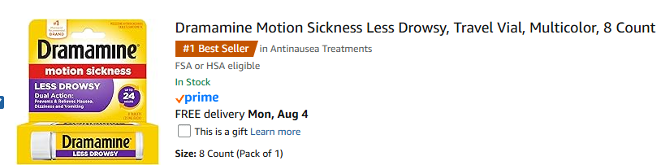

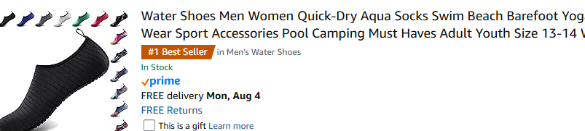

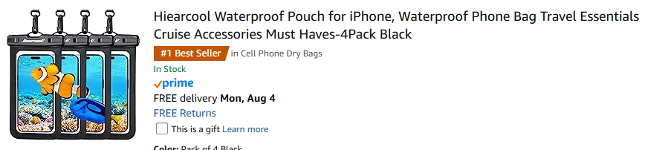

ITEMS OF INTEREST FOR THE MAROONED TRIP.

